3rd February 2021
Dear Parent of P6 and P7 children
We would like to take this opportunity to invite you and your child(ren) to attend our forthcoming Virtual Open Evening on Thursday 11th February 2021, 7.30pm.
We hope that our Open Night will give your son/daughter a taste of what it means to become a pupil at Dromore High School.
There will be a combination of live and pre-recorded video streaming on YouTube, Collaborate Ultra and our special Open Night website (details below). The presentations provide a mixture of both pastoral and curriculum information. As a follow up, our Senior Leadership Team will chat with parents online through a Q & A session on Friday 12th February, 2.00pm-3.00pm.
Please follow us on social media so you can access our website link and/or QR code. The Open Night website will entail all relevant links and online services required for the evening:
https://sites.google.com/c2ken.net/dromore-high-open-night/home
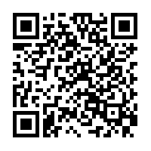
The home page is accessible at present but all other material will be released on 11th February.
We look forward to welcoming you to Dromore High.

Yours faithfully
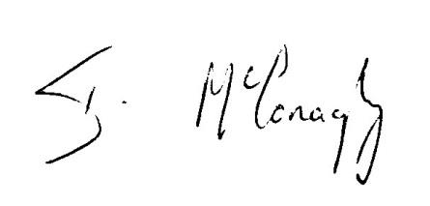
Mr I McConaghy Mrs W Kirkland
Principal Director of KS3

