Happiness is

Happiness is out in our fields playing with fluffy lambs . 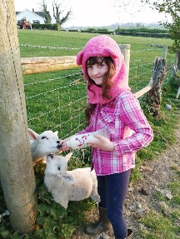 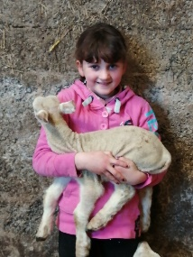 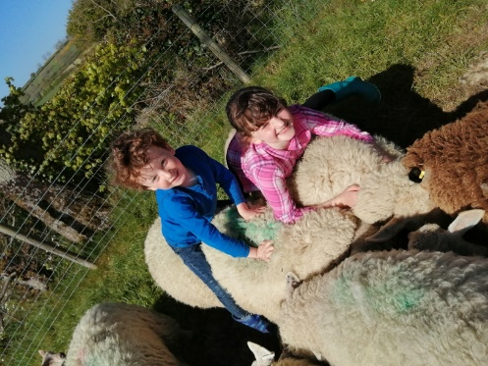
It is the best feeling ever.
Happiness is swimming in the paddling pool 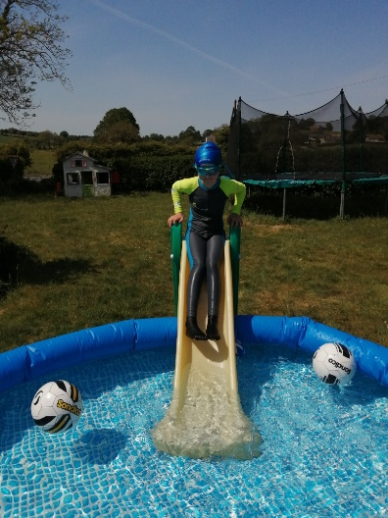
And singing in the sunshine.
Happiness is walking your dog .
Feeling happy.
Eating rocket lollies and chocolate puddings.
Knowing that there are more in the freezer….
Happiness is zooming down hills when you are cycling
And playing with friends.
By ELIANNA 