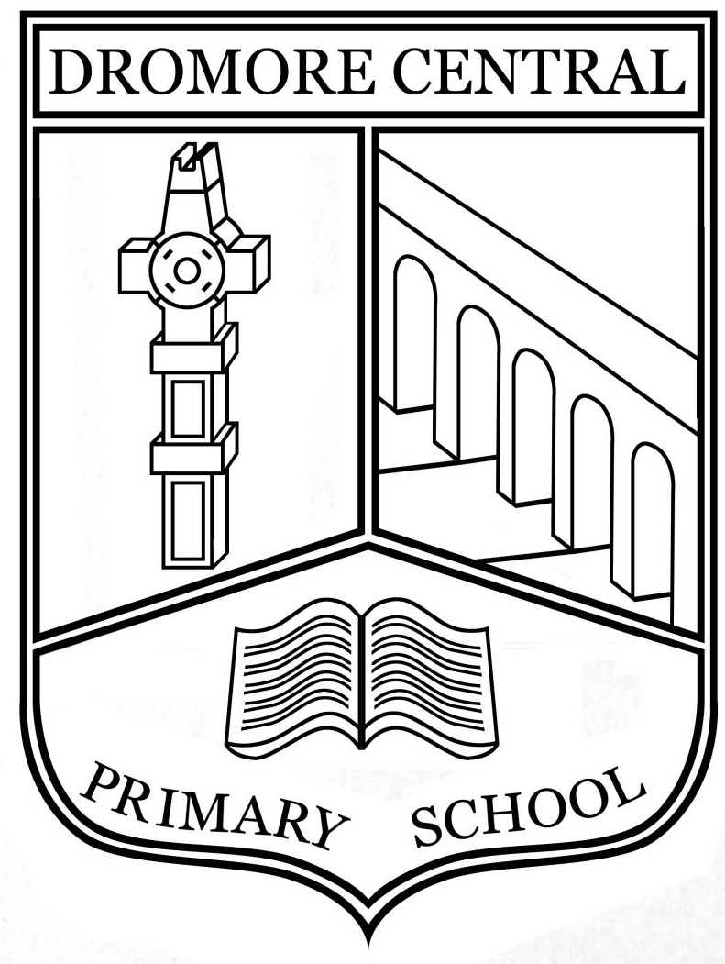

Interview Record

Dromore Central Primary School

E-Safety Policy

Acceptable Use of iPads

June 2023

Table of Contents

- Users’ Responsibilities (including members of staff) Page 3
- Safeguarding and Maintaining as an Academic Tool Page 3
- Lost, Damaged or Stolen iPad Page 4
- Prohibited Uses (not exclusive) Page 4
- Acceptable Use of iPads for Staff Page 5
- Acceptable Use of iPads for Pupils, Key Stage 2 Page 6
- Acceptable Use of iPads for Pupils, Key Stage 1 Page 7
- Acceptable Use of iPads for Pupils, Foundation Stage Page 8

Acceptable Use of iPads Policy
Ratified by Board of Governors (Date)_____________
Signed: __________________________________________
Review Date: June 2023
At Dromore Central Primary School iPads are used for digital storytelling, internet research, and much more, to support learning and teaching across the curriculum via the use of a range of appropriate apps. When using iPads, children will be reminded to be Internet SMART and apply the Internet Safety Rules.

The policies, procedures and information within this document apply to all iPads or any other ICT handheld device used in school. Teachers and other school staff may also set additional requirements for use within their own classroom/resource area.

Users’ Responsibilities (including members of staff)

- Users must use protective covers/cases for their iPad.

- The iPad screen is made of glass and therefore is subject to cracking and breaking if misused: neither drop nor place heavy objects (books, laptops, etc.) on top of the iPad.

- Only a soft cloth or approved laptop screen cleaning solution is to be used to clean the iPad screen.

- Do not subject the iPad to extreme heat or cold.

- Do not store or leave unattended in vehicles.

- Users may not photograph any other person, without that persons’ consent.

- The iPad is subject to routine monitoring by Dromore Central Primary School.

- Devices must be surrendered immediately upon request by any member of staff.

Safeguarding and Maintaining as an Academic Tool

- All iPads are linked to the c2KWireless system and should not be connected to another internet service.

- iPad batteries are required to be charged and be ready to use in school. Devices should not be left charging over night or during holidays due to fire safety.

- Items deleted from an iPad cannot be recovered.

- Memory space is limited. Deletion of photos and videos should happen periodically by staff members.

- iPads must always be returned after use and are never to be taken home by children.

- All staff iPads must be in school each day. The only exception is job-share teachers, who have their individual iPad that may be at home on their days off.

- If an iPad is found unattended, it should be given to the nearest member of staff, who can return it to the teacher named on the label.

Lost, Damaged or Stolen iPad

- If an iPad is lost, stolen or damaged, Mrs Adams or Mrs Snoddy must be notified immediately.

- iPads that are believed to be lost/stolen can be tracked through the iPad management system, Mosyle.

Prohibited Uses (not exclusive):

- Accessing Inappropriate Materials – All material on the iPad must adhere to the ICT Policy and the Mobile Digital Devices Policy.

- Illegal Activities – Use of the school’s internet/e-mail accounts for financial or commercial gain or for any illegal activity.

- Violating Copyrights – ICT co-ordinators are the only members of staff who can install apps on the iPads.

- Cameras – Users must use good judgment when using the camera. The user agrees that the camera will not be used to take inappropriate photographs or videos, nor will it be used to embarrass anyone in any way.

- Posting of images/movie on the Internet into a public forum is strictly forbidden, without the express permission of the Teacher or in the case of staff use; the ICT Co-ordinator/s.

- Use of the camera and microphone is strictly prohibited unless permission is granted by a teacher.

- Misuse of Passwords, Codes or other Unauthorized Access: Only the ICT Co-ordinators can set the iPads’ passcodes using Mosyle management.

- Malicious Use/Vandalism – Any attempt to destroy hardware, software or data will be subject to disciplinary action.

- Jailbreaking – Jailbreaking is the process which removes any limitations placed on the iPad by Apple. Jailbreaking results in a less secure device and is strictly prohibited.

- Dromore Central Primary School reserves the right to confiscate and search an iPad to ensure compliance with this Responsible Use Policy.

In order to ensure that the iPads in our school are used correctly, all teachers are required to sign the agreement on the following page.
Acceptable Use Policy for iPads

School name: Dromore Central Primary School DE Number 501-1575

iPad serial number_______________________ Teacher_______________________________

This policy should be signed by any member of staff who uses an iPad in or away from the school.
I understand that I am the nominated member of staff for this iPad and I agree that:
(Please tick each box)
I will ensure that the iPad is stored securely at all times.

The iPad should always be carried in its protective cover to reduce the chance of damage.
To enforce a six digit security PIN on the device and ensure the PIN is held only by ME and not divulged to pupils.
Use of the iPad should be considered the same as any other technology tool provided by the school.
The ICT Coordinators will provide a list of curriculum apps and install them on the iPads, when required. If you need to buy an app please contact the ICT Coordinators.
To use only an account in the name of the school with your email address for all App purchases.
To not install any apps that may be considered only for your own personal use, or
could be deemed not suitable for the classroom. I may download free curriculum apps.
Use of non-curricular videos, games or movies is not permitted when on the school network.
To ensure that all apps meet with the requirements of the schools Acceptable Use of the Internet and E Safety Policy.
Use of the iPad, both in and outside school, is subject to the school’s Mobile Digital Devices Policy.
To not use the device to store personal documents such as videos, photos or audio material other than which is directly related to your school needs.
Use of the iPad should be considered the same as any other technology tool provided by the school.
To not allow any pupil to use the iPad for any purpose except for curricular purpose
under a controlled environment in the presence of a member of staff.
Use of the camera only permitted in line with the whole school
Child Protection Policy.
The iPad may be used outside school for Internet use with any Internet Services
Provider (ISP).
The iPad should not be given or lent or used by anyone other than the nominated
member of staff when outside school.
If the iPad is lost, stolen or damaged please report it immediately to the Principal and ICT Coordinators.
In the case of loss, theft or other damage occurring outside of school, to repair,
replace or make good the iPad to its original state.
I will not use Facebook or any form of social networking sites on the iPad for personal use while in school. (Please refer to our Social Networking Policy.)
Ownership of this iPad rests with Dromore Central Primary School. I may retain it for school use while in the employment of this school.

Staff Signature:____________________________________________ Date: ______________
In order to ensure that the iPads in our school are used correctly, all pupils in Key Stage 2 and their parents are required to sign the agreement below.

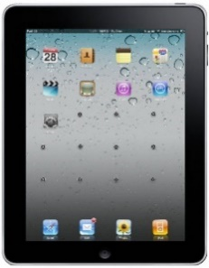
Dromore Central
Primary School
Key Stage 2
Acceptable Use Policy for iPads

This policy should be signed by any pupil from Dromore Central Primary School who uses an iPad in school.

I understand that I am only allowed to use a school iPad if I agree that:
(Tick)
I must keep the iPad in its protective cover.

The iPad screen is made of glass and therefore is subject to cracking and breaking if misused.
I must never drop nor place heavy objects (books, laptops, etc.) on top of the iPad.

Use of the iPad should be considered the same as any other technology tool (e.g. laptop) provided by my school.
I may NOT photograph or record any other person, without that persons’ consent and my teacher’s permission.
The iPads are subject to routine monitoring by Dromore Central Primary School.

I must not install any apps for my own personal use, or that could be deemed not suitable for the classroom.
Use of non-curricular videos, games or movies is not permitted when I’m on the school network.
Dromore Central Primary School is not responsible for the financial or other loss of any personal files that may be deleted from an iPad.
I must not use the iPad in school corridors or outside the school buildings (unless with my Teachers’ permission).
If I break any of these rules, I may be subject to; disciplinary action, confiscation, removal of content or referral to external agencies in the event of illegal activity.
The iPad may not be used outside the grounds of Dromore Central Primary School.

Syncing the iPad to my personal iTunes or iCloud account is not permitted.

If the iPad is lost, stolen or damaged I must report it immediately to the Principal or either of the ICT Coordinators.
iPads belonging to other users are not to be tampered with, in any manner.

If I find an iPad that is unattended, it should be given to the nearest member of staff.

Pupil Signature:_________________________________

Parent’s Signature: _______________________________________

Date:________________________
In order to ensure that the iPads in our school are used correctly, all pupils in Key Stage 1 and their parents are required to sign the agreement below.
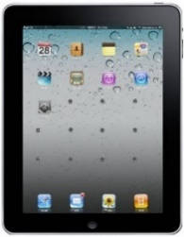
Dromore Central Primary School
Key Stage 1
Acceptable Use Policy for iPads

I will keep the iPad in its cover.

I will look after it carefully when I am using it.

I must never drop it.

I must not place heavy objects (books, laptops, etc.) on top of the iPad.

I will NOT photograph or record any other person, without their permission.
I will not install any apps on the iPad.

I will not play games, videos or movies when I’m on the school network.

I must not use the iPad in school corridors or outside the school buildings (unless with my Teachers’ permission).
If I break any of these rules, I will no longer be allowed to use an iPad at school.
The iPad may not be used outside the grounds of Dromore Central Primary School.
Syncing the iPad to my personal iTunes or iCloud account is not allowed.

If the iPad gets damaged I must report it immediately to my teacher.

iPads belonging to other users are not to be tampered with.

If I find an iPad that is unattended, it should be given to my teacher.

Pupil Signature:_____________________________________________

Parent’s Signature: ___________________________________________

Date:_________________

In order to ensure that the iPads in our school are used correctly, all pupils in Foundation Stage and their parents are required to sign the agreement below.
Dromore Central Primary School
Foundation Stage
Acceptable Use Policy for iPads

I will keep the iPad in the cover.

I will look after it.

I must not drop it.

I must not put heavy things on top of the iPad.

I will NOT photograph or record without asking my teacher.

I will not play games, videos or movies.

I must not use the iPad outside my classroom.

If I break any of these rules, I will not get to use an iPad.

If the iPad gets damaged I will tell my teacher.

I will not touch other children’s work on the iPad.

If I find an iPad I will tell my teacher.

Pupil Name:_____________________________________________

Parent’s Signature: ________________________________________

Date: ___________________________

