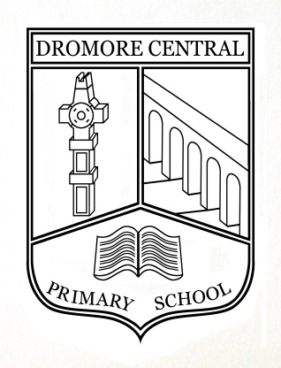 | Dromore Central Primary School  25 Mossvale Road  DROMORE  BT25 1DG  Tel: 028 9269 2134  Principals: Mrs L M Allen MEd DASE (Sc) PQH ALCM  Mrs H M Bentley Bed (Hons) PQHNI

29 August 2023

Dear Parents

We hope you have managed to enjoy some rest and relaxation over the past weeks and are looking forward to returning to school.

Just to remind you:

Tuesday 29 August 2023 P3, P5 and P7 attend school
Wednesday 30 August 2023 P2, P4 and P6 classes to attend
from Thursday 31 August 2023 P2 to P7 classes all attend

Please note new P1 classes have already been notified of their own arrangements.

Children are asked to bring packed lunches into school as there will be no school meals served until Friday 1 September 2023.

School finishing times will be as follows:-

P1 1.55pm (from October onwards)
P2 2.00pm
P3 2.40pm (Monday to Wednesday)
2.05pm (Thursday & Friday)
P4 2.40pm
P5 2.50pm
P6 2.55pm
P7 3.00pm

We look forward to seeing everyone back in the next few days.

Yours sincerely

L M Allen & H M Bentley

Co-principals

